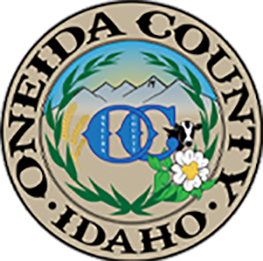
ONEIDA COUNTY COMMISSIONERS
Bill Lewis, Chairman – Ken Eliason – Brian Jeppsen
Meeting Location: Event Center
459 South Main St., Malad, Idaho
AGENDA – Regular Commissioners Meeting
26 May 2026 - 9:00 a.m.

Approve Agenda | Action Item
Billing for Election Day Internet Outage Resolution | Action Item
Consent Agenda: Payment of Claims, Certificate of Residency and Approval of Meeting Minutes | Action Item
Board of Equalization, if needed | Action Item
Mike Asay Subdivision | Action Item
Canvas of the May 19, 2026 Primary Election Results | Action Item
Back-up Internet Options | Action Item
Courthouse & Summit Generators – Sheriff’s Department | Action Item
Vehicle Use / Travel Policy | Action Item
Development Code – 7th Amendment Approval | Action Item
Quotes for Projected R&B Purchases for FY2027 | Action Item
Changes to the Oneida County Road Ordinance No. 2009-02-01 | Action Item
Changes to the Highway Standards & Road Development (HSRDP) | Action Item
Bid Process for Propane Contract (7/1/2026 – 6/30/2027) | Action Item
Helicopter Spraying Project with the Forest Service - Weed Department | Action Item
Water Study Report and Follow-up Public Outreach & Budget Needed | Action Item
Department Updates & Highlights - 12:00 p.m.  (Sheriff, P&Z, Attorney, Probation, Fair, VSO, Coroner, Hospital, Parks & Recreation, Extension, Assessor) | Discussion
Pool / Southeastern Idaho Public Health (SIIPH) Inspections | Discussion
Petty Cash Funds in Extension 4-H and Fairboard | Action Item
Private Burial Grounds Ordinance | Action Item
Oneida County Annual Juvenile Justice Report (2025) – Stace Gearhart – 1:30 p.m. | Action Item
Oneida County Probation Policy Manual - Approval of Updates | Action Item
Court House flagpole | Action item
1:00 – Recess for Lunch

